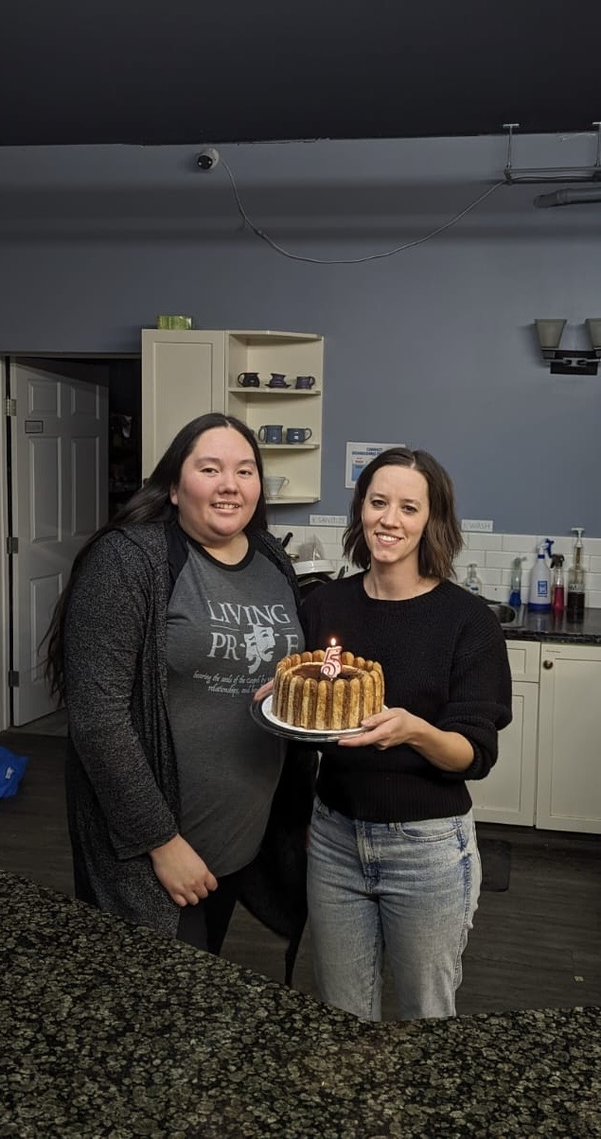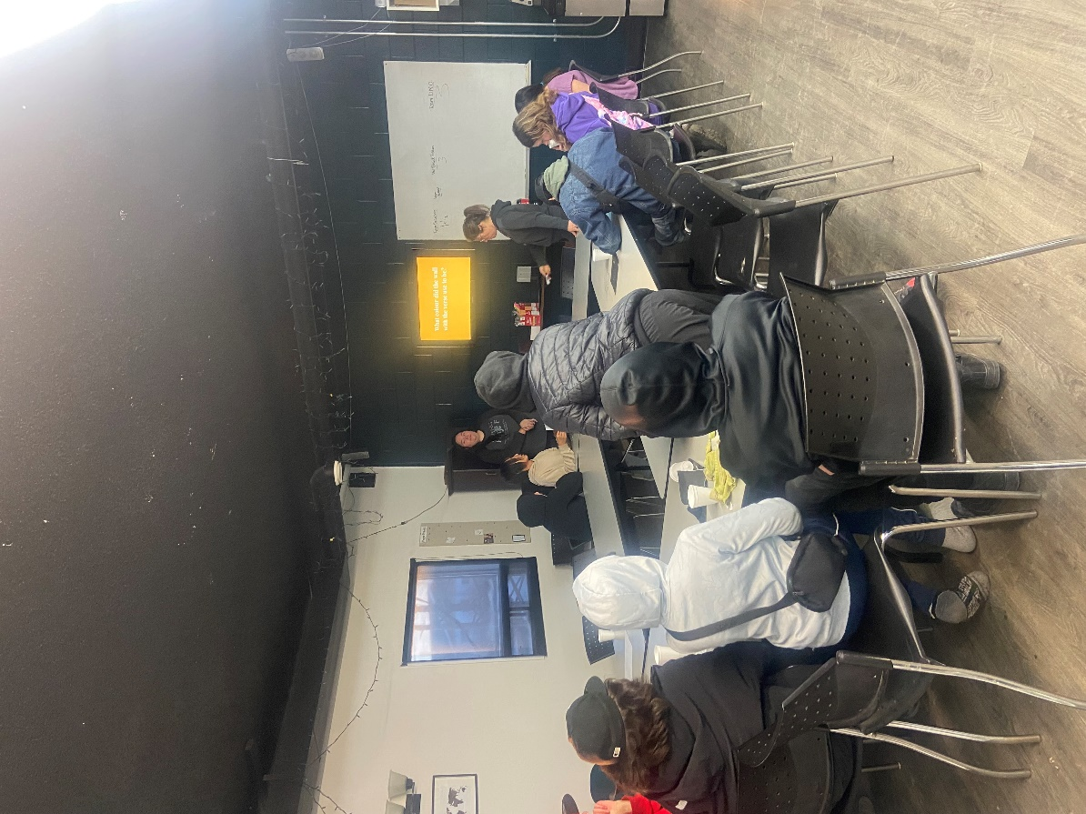
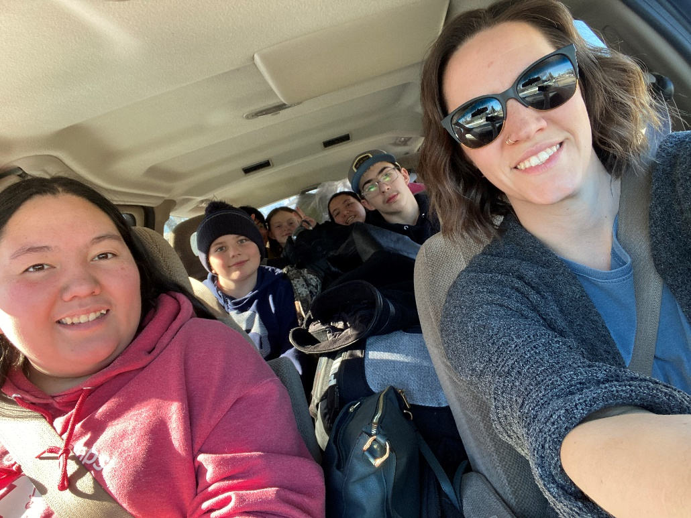
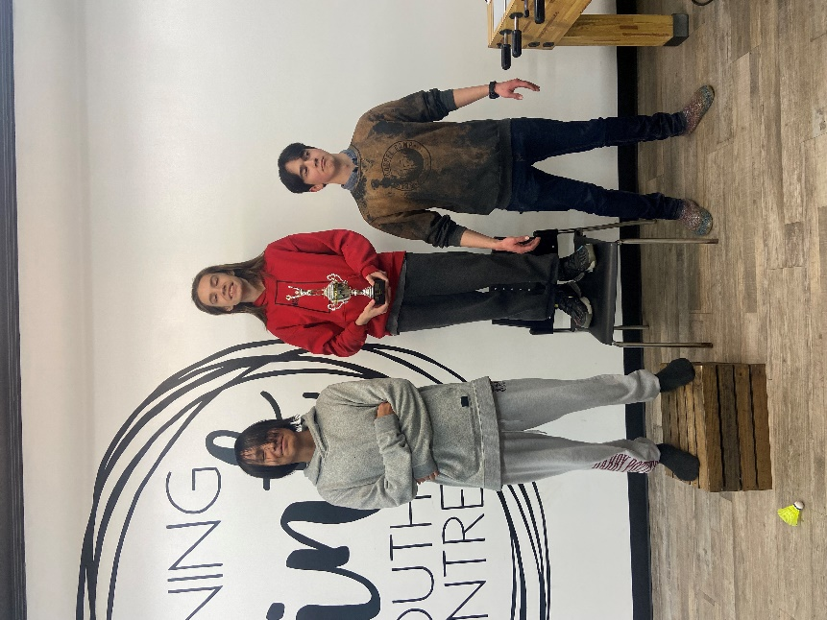
March was a busy month!
Quick Update:
- March 22 marked 5 years since we opened! We had a nice celebration with our youth that Friday.
- We hired a new part time staff, Brandon! He is pictured above, having proudly won bronze in our last Smash Bros tournament.
- Jeralee and Belinda took youth to Saskatoon, plus travelled to Nipawin, Calgary and Three Hills for speaking engagements.
Prayer Requests:
- We are thankful that God provided a part time staff for us! He is here for 3 months, and we are happy to have him for that length of time.
- We are thankful that God has provided everything we have needed over the last 5+ years.
- Pray for wisdom and support for Belinda and Jeralee. This is a tough job and we need all of the help and prayers we can get!
- Pray that we continue to glorify God in everything we do. The only reason we exist is to share the Gospel with the youth who enter here. Also pray for the hearts of the youth who come here.
- Continue to pray for the Alpha Program.
- We are still looking to hire a program director for August, when Jeralee leaves, as well as a part time youth worker after Brandon leaves in July! Pray that the right people would apply.
- We have a large group of rowdy youth who has started to come. It is wonderful to have them here but also tiring. Pray that we would be able to love and teach them well.
- Pray in general for the future of the youth centre! Pray that everyone involved is able to hear God's voice and that we are equipped to do His will.
We appreciate your prayers more than you know! God's provision is the only reason we are still open and you play a huge part by going to God on our behalf, so thank you.
Blessings,
Belinda, Jeralee and Brandon!

Copyright © 2024 Turning Point Youth Centre, All rights reserved.
You are receiving this email because you opted in via our website.
Our mailing address is:
Box 335
Meadow Lake, Sk
S9X 1Y3
E-transfer:
turningpointyouthcentre@gmail.com

