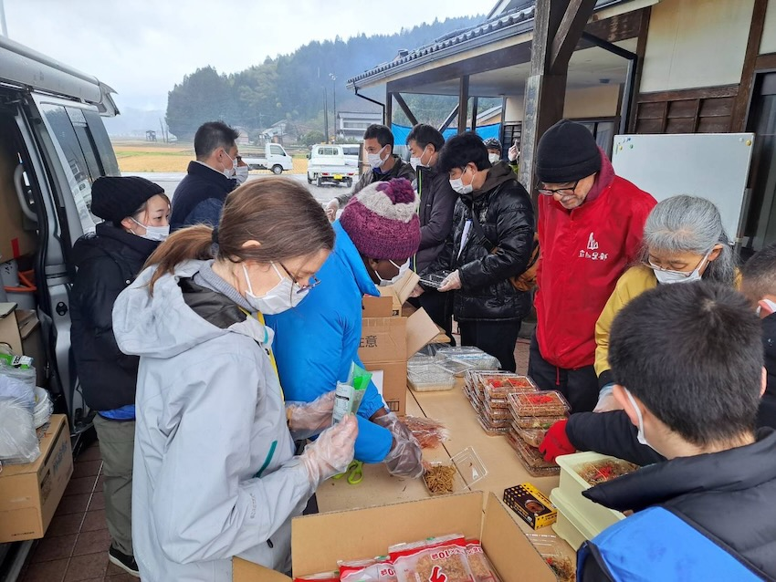
Sandy and kids packed lunch for the survivors of the earthquake in a cold rainy day.
We are thankful that the whole family and OM Mie team can come up to take part in the disaster relief program.
Dear praying friends,
Thank you for your prayers. After Kenji’s last trip to Noto earthquake affected area, he was asked to speak at churches and relief organizations in Japan because they wanted to know the disaster situation/church situation/road access.
Then in January OM Mie team & Kondo family (including our home-schooled children) went to Noto, not only to get involved in the relief work, but also to help our OM colleagues who were affected by the earthquake. Today we want to tell you about the 2nd trip to Noto peninsula, along with other 2 major events where we saw God moving in Japan.
PRAYER Requests for Upcoming 3 trips
- FEB 22-MAR 3, for Kenji & Shinji going to Singapore & Indonesia.
In Singapore, Kenji will be speaking twice about Japan to encourage people to pray & go.
In Indonesia, Kenji will be attending a global conference put on by GCPN (Global Church Planting Network) while Shinji (17) will spend time with Indonesian youth for a cross-cultural experience. PRAY for a Safe journey, wisdom, health & strength, and Shinji’s time with youth. PRAY that Sandy and kids will guard the fort while Kenji & Shinji are gone.
- MAR 14-20, Kenji will fly to Indonesia to be an interpreter during OM’s INTL conference. He will be interpreting for OM Japan’s director and his wife. PRAY for a Safe journey, and clarity of mind for interpreting for 4 days.
- MAR 25-28, all Kondos will go to Fukui Prefecture, Japan for the annual OM Japan retreat. This is the only time for all OM missionaries to come together each year. Kenji is the leader of this year's retreat organizing committee (made up of 11 people).
Noto Earthquake Report
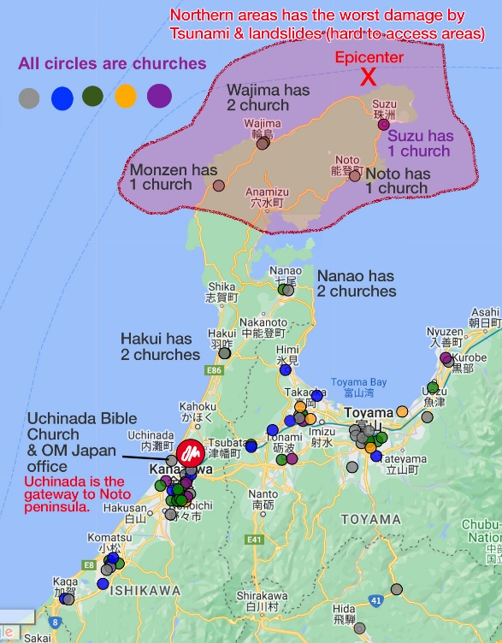
Until now:
The large-scale earthquake hit the Noto Peninsula in Ishikawa prefecture on January 1st of this year---causing massive destruction and many landslides. Because Noto is one of the area’s OM missionaries have been working, OM missionaries started relief work from day 2, surveying road access, and delivering supplies. Most notably, God used OM to gather key local pastors and denominations to start an inter-denominational Christian disaster organization called "Noto-HELP".
“Takidashi” (feeding) program (whole family)
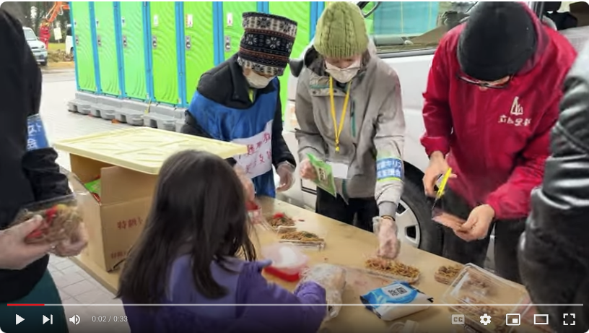
Watch Sandy and children packing lunch for evacuees, with the pastor of Monzen (in Red jacket). Length: 34s
https://youtu.be/sUZHYdphxtk
We drove up to the town of Monzen with 2 other vans. It was a rainy day. We set up an outdoor kitchen at a community center which housed about 80 people. These residents had evacuated from nearby villages where people could not return after the quake due to the landslide covering the roads. Sandy and the kids helped pack 200 plates of fried noodles for these residents as well as surrounding evacuation centres. In the meantime, Kenji was serving coffee to the old men who were warming up around a fire outside. As he served, some men wanted to visit and talk. Kenji was able to pray with two of them.
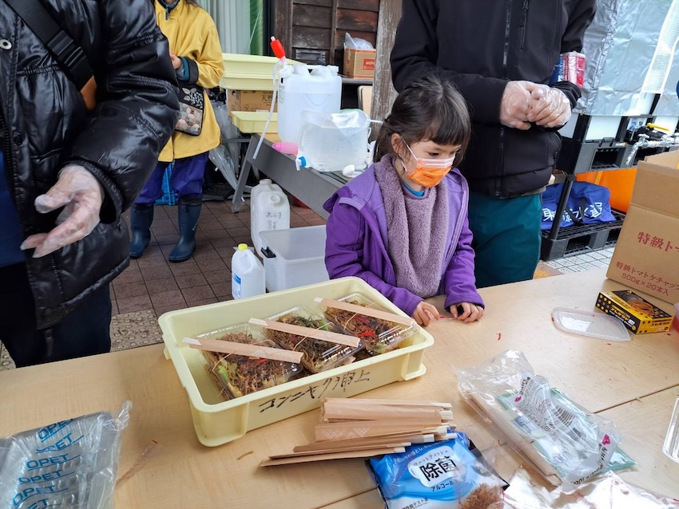
The presence of our children comforted the hearts of both the survivors and the pastors because they don't usually see children. Most of the badly affected areas struggle with super-aging where the percentage of senior citizens (65 and above) make up about 45-51% of the entire population.
Helping our colleagues in the affected area:
OM Japan has a number of missionaries in & around Noto peninsula. We went to support the W family (Hong Kong) by looking after kids after school so that the parents could go out to run a feeding program and deliver supplies. We are thankful to God that our kids, Satoshi & Mizuki, played with W’s kids very well. The parents were blessed to see the kids enjoying playing together in their homes after the traumatic experience during the earthquake.
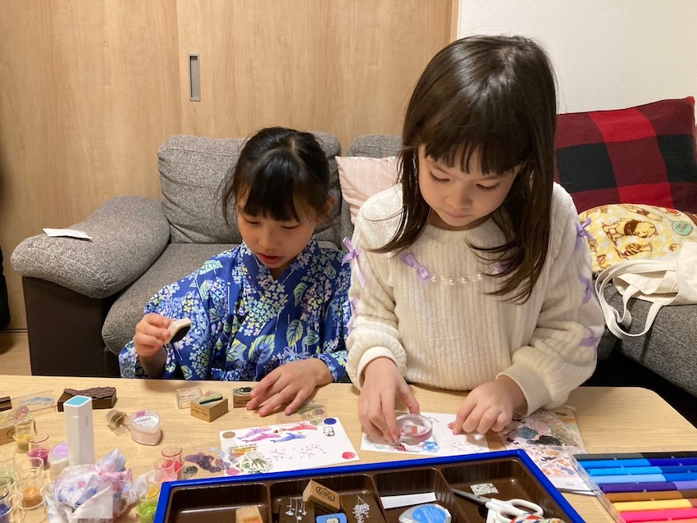
Mizuki playing with one of W family's kids. After living out of their home for 2 weeks, W is finally back at their home. Seeing their children be able to play at their home brought a sense of "normal" in the abnormal circumstances in the peninsula.
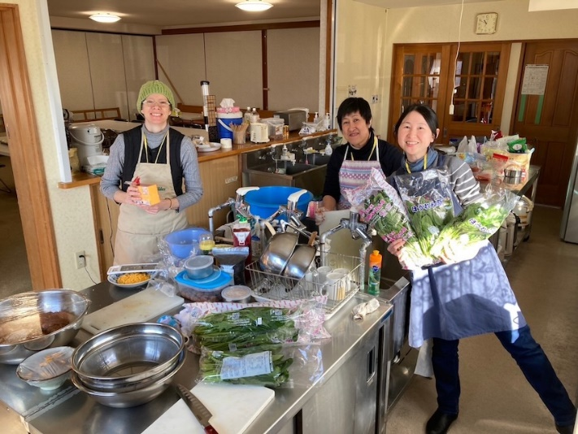
Cooking for staff at relief work base:
Sandy and OM Mie team (M and J) worked in the kitchen of the relief work base providing food for staff and volunteers. This base, which is housed inside a church building, is where 2 OM missionary families are assigned.
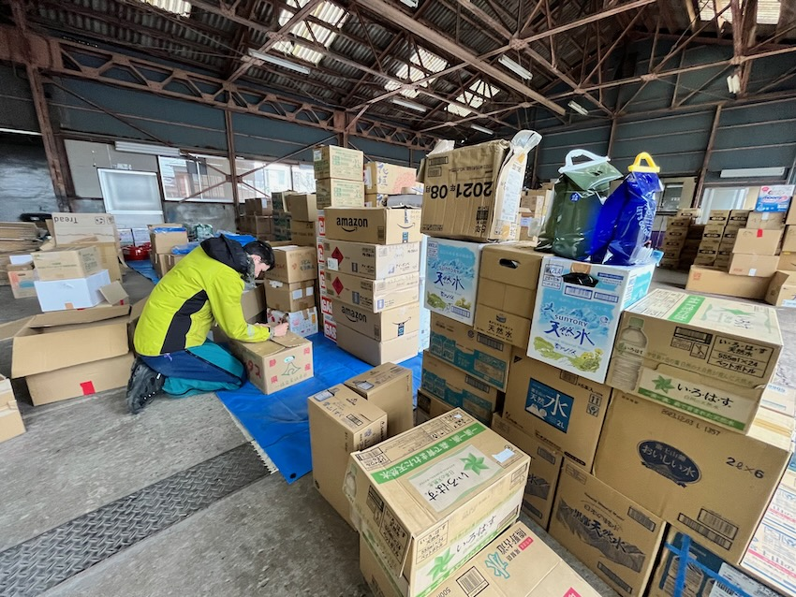
Working at a relief supply warehouse (Shinji & Kenji):
Shinji and Kenji spent two days working at the warehouse. Though supplies were brought in by Christians from all over Japan, there had been no one organizing the warehouse. Shinji and Kenji got to sort and count supplies. It was a joy to meet Christians from different parts of Japan as people came to drop off supplies (water, kerosene, etc.)
Visiting Tsunami site in Suzu City (Shinji & Kenji)
Shinji (our oldest son) and Kenji spent 1 day going to the city of Suzu with 2 OM colleagues. Suzu was one of the closest areas to the earthquake epicentre and was hit by a tsunami.
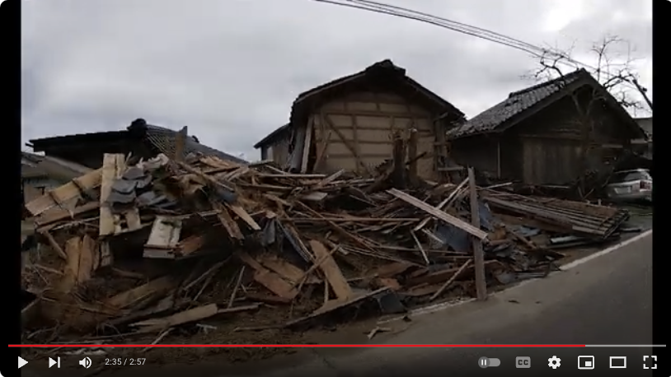
https://www.youtube.com/watch?v=XR62DdbKhjU
Length: 2m57s
Driving along the coast, leading up to the city, the houses on both sides of the road were badly collapsed for about 2-3 km.
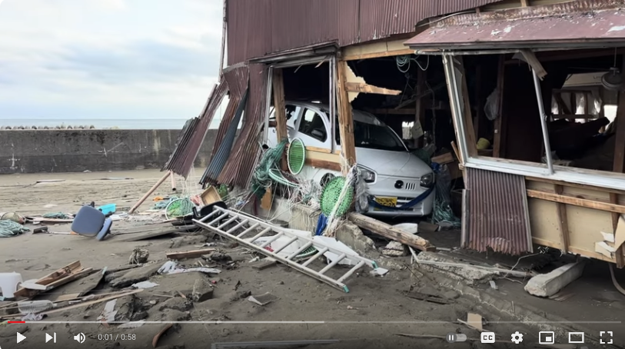
Tsunami aftermath
After delivering supplies to a school building turned into an evacuation center, we walked into the Tsunami site. These videos can speak better than words.
https://youtu.be/a9Y5QNK-D7Q
Length 59s
https://youtu.be/avB_G42SOZI
Length 38s
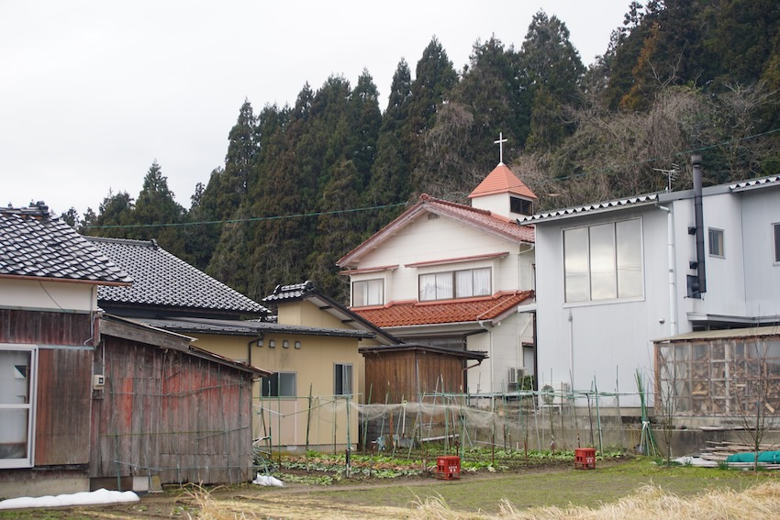
Pray for the Suzu Christian Center (SCC):
SCC is Suzu City’s only church. It has a congregation of only 2 ladies. The elderly female pastor moved into an old folks home in another city last fall (3 months before the earthquake). On January 1st, the earthquake collapsed both ladies' homes, one of them had to crawl out of the building and spent the first night on a hilltop because of the fear of aftershocks and tsunami. (Indeed Suzu city was hit by a Tsunami)
Now the 2 ladies are living out of the church building as they work as nurses during the day. PRAY for the two ladies for their PTSD, physical/emotional/spiritual well-being.
PRAY that they can start trusting other Christians. This independent rural church made hardly any communication with outsiders. Thus, the congregation is skeptical of other Christians. A well-known relief organization’s president once stated, “Japanese are extremely reluctant to receive help from others.”
PRAY for wisdom & sensitivity as Christian organizations approach SCC for their needs and start developing trust.
National gathering of Pentecostal Churches
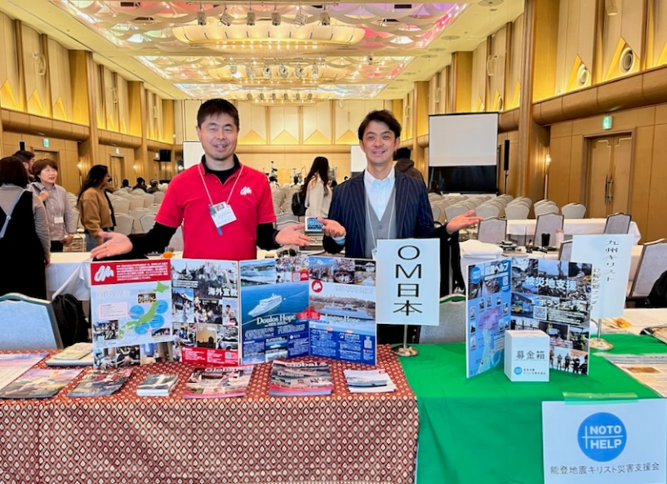
Raising awareness
Kenji went to attend the annual conference held by Japan Pentecostal Fellowship. He set up 3 booths that included the new disaster relief org “Noto-HELP”. Along with that, Kenji manned booth for OM and another organization together with 3 pastors. As Kenji attends this every year, he can see God taking down the walls between Japanese denominations more and more.
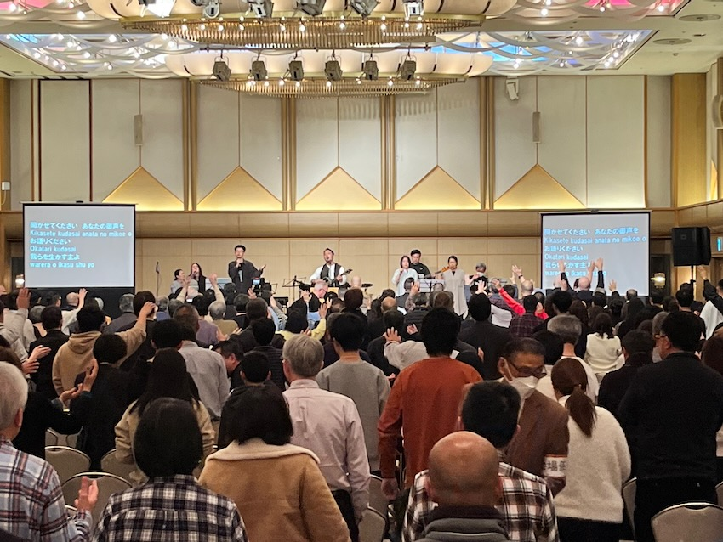
2 Day events in Mie prefecture:
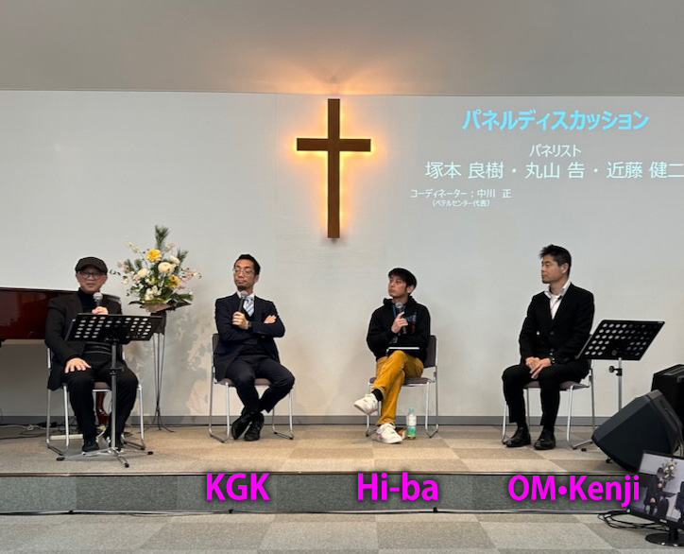
1st Day, Gen-Z seminar:
A local Japanese church put on an event inviting 2 experts from Hi-ba (high school ministries) & KGK (university ministries) to learn about how to make their church as a home for Generation Z. Kenji was invited to speak as a plenary speaker to paint the picture of the state of Mie churches. Because Mie has a problem with depopulation and a lack of young people, Gen-Z is a huge issue for Mie churches.
We are thankful that this event was made available inter-denominationally to Mie churches. It ended up attracting 70 people, representing 28 churches. (In Mie, this is a huge number!)
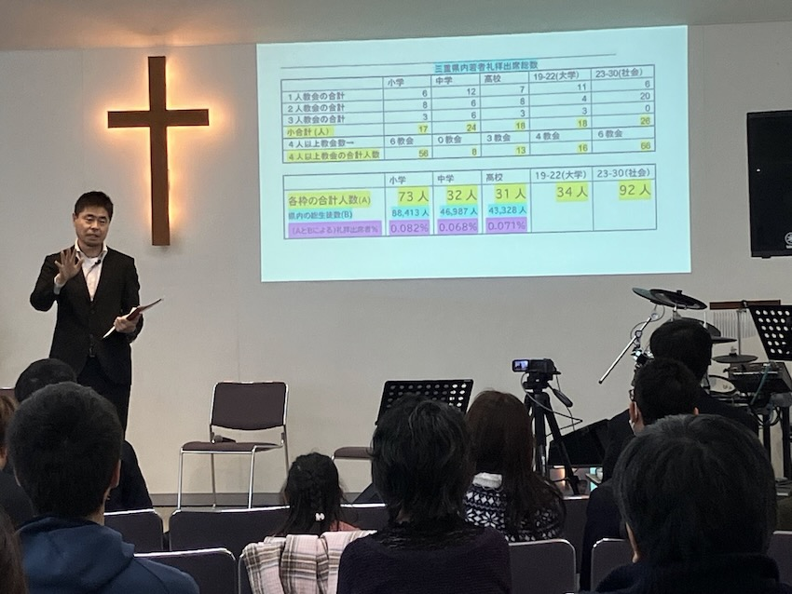
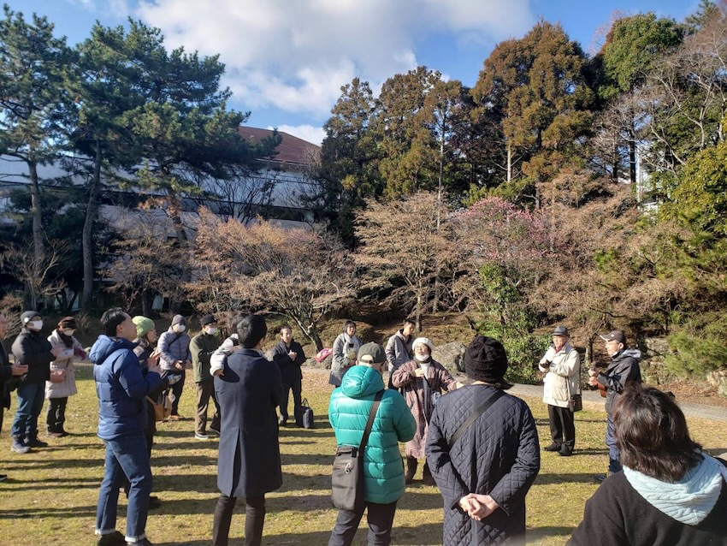
30 Christians from 11 different churches gathered in person to pray outside a municipal office.
2nd Day, Annual Mie Prefectural Prayer:
30 Christians from 11 different churches gathered in person to pray outside a municipal office. They prayed for the World, Japan and Mie. After that, we gathered again inside a church building for an online meeting where Kenji led. We had 3 other presenters from different parts of Mie to share their evangelism efforts which were broadcasted by YouTube and Zoom.
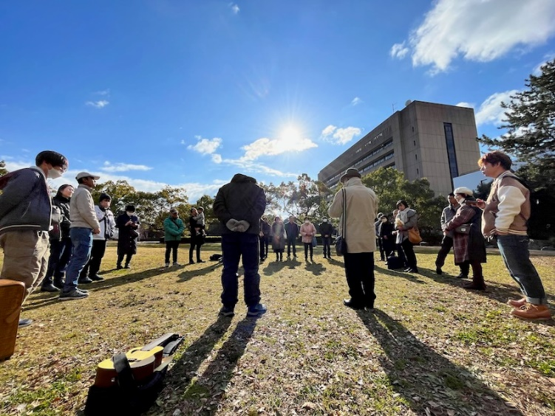
This was a long report but I hope it gave you a glimpse of how God is moving things in Japan. We continue to covet your prayers because we can NOT do what we do without your support & prayer.
For His glory
Kenji & Sandy Kondo
Family Moment
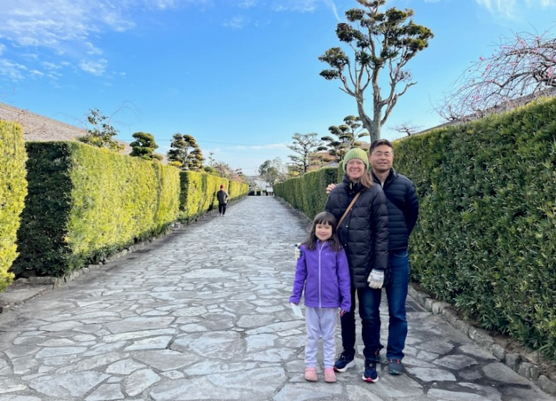
Sandy, Mizuki and Kenji visited this Samurai residential area, called "Gojoban Yashiki" (built in AD1860) in Matsusaka city. It was cold but wonderful! We had a relaxing walk discovering the historical town while the two boys were racing in the Mini4WD circuit nearby.

Kenji & Sandy Kondo are missionaries with OM residing in Reiho, Japan where Kenji was born. They live and work as evangelists with their 3 children and Kenji's mom. Their town, Reiho, is more than 2000 years old and never had a gathering of believers, until recently.
OM (Operation mobilization) is a global mission organization working across 118 different countries for evangelism, church planting, discipleship, disaster & refugee relief as well as fighting against drug & human trafficking.

