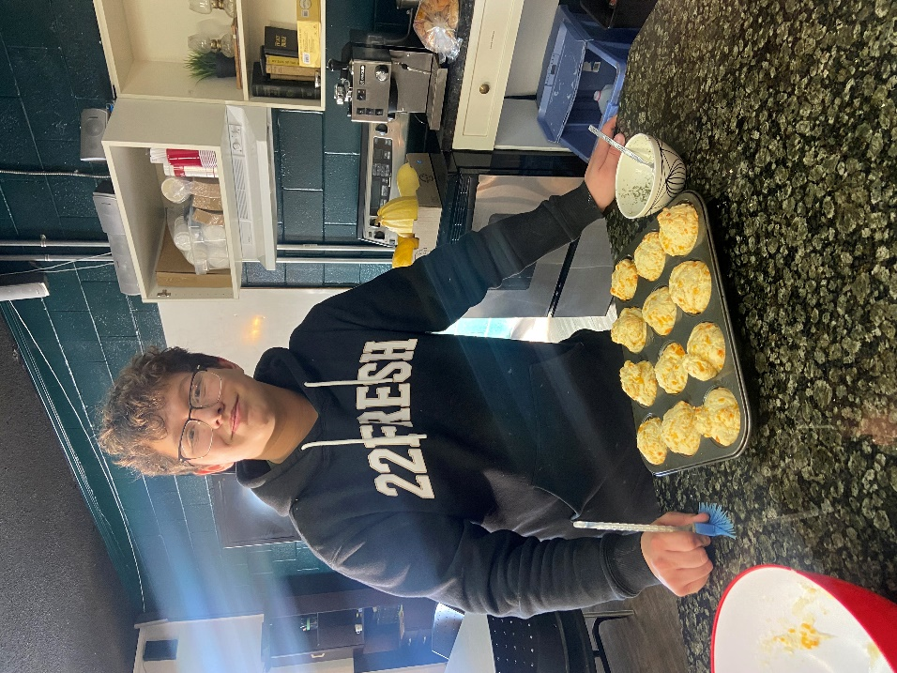

It's Almost Spring!
We love that the days have been getting longer! Our youth have been enjoying our outdoor basketball net this last week, which has been refreshing!
Quick Update:
March 22 marks 5 years since we have been open! Praise God, what a great milestone.
Prayer Requests:
- Pray for wisdom and support for Belinda and Jeralee. This is a tough job and we need all of the help and prayers we can get!
- We are bringing a group of youth to an overnight youth event in Saskatoon March 15-16 called Inspire Our Nation! Pray for safety, fun and that the youth would be impacted in a positive way.
- Belinda and Jeralee will also be travelling quite a bit this month to different Bible Colleges and supporting churches! Pray that God would use this time and effort effectively.
- Pray that we continue to glorify God in everything we do. The only reason we exist is to share the Gospel with the youth who enter here. Also pray for the hearts of the youth who come here.
- Pray for the Alpha Program that we started last month. We will be running it every Tuesday until it's over.
- We are still looking to hire a program director for August, when Jeralee leaves, as well as a part time youth worker who will be here for drop in hours only. Pray that the right people would apply.
- Pray in general for the future of the youth centre! Pray that everyone involved is able to hear God's voice and that we are equipped to do His will.
We appreciate your prayers more than you know! God's provision is the only reason we are still open and you play a huge part by going to God on our behalf, so thank you.
Blessings,
Belinda and Jeralee

Copyright © 2024 Turning Point Youth Centre, All rights reserved.
You are receiving this email because you opted in via our website.
Our mailing address is:
Box 335
Meadow Lake, Sk
S9X 1Y3
E-transfer:
turningpointyouthcentre@gmail.com

